Scientific Report

We are very grateful for the grant funding received from Arthritis Australia in support of our project “*Personalised Medicine in the Treatment of Ankylosing Spondylitis”.*

1. *What were the main scientific objectives of the grant?*

Use of Biologic DMARDs in treatment of AS is common. Current ACR guidelines recommend use of TNF inhibitors in patients with active AS for whom NSAIDs are ineffective [3] while EULAR guidelines also recommend use of IL-17 inhibitors [4]. Biologic DMARDs (bDMARDs) have revolutionized treatment of AS, however, there are some cases in which a change from one bDMARD to another is necessary because of the refractory nature of disease or due to co-morbidities. Yet, there are no well-established methods for selecting the optimal bDMARD that take the individuals genetic or immunological profiles into consideration. Similarly, as more bDMARDs are licensed for use in AS it becomes more challenging for clinicians to determine which of these should be used as first line therapy for individual patients. In other words, as treatment options become more extensive in AS there is a need to develop screening methods to enable logical and robust decision making and facilitate precision medicine approaches to treatment.

***Our overall hypothesis was that immune cell profiling predicts effectiveness of bDMARDs in the management of ankylosing spondylitis.***

We addressed this hypothesis with the following aims:

1. Use flow cytometry to profile immune cells from AS patients who have responded well or poorly to treatment with either adalimumab or secukinumab.
2. Use RNA-seq to further define signatures of immune cell function that enhance prediction methods

The overall stated goal of this study was to generate proof-of-principle data that would support a larger cohort study.

1. *What were the main scientific achievements of the grant? Your answer should be at least 200 words.*

From a biobank of patient peripheral blood mononuclear cells (PBMC) we selected two groups of patients: (i) patients with clinical improvements on adalimumab (n=10), (ii) patients with clinical improvements on secukinumab) (n=6).

We developed two cytometry panels, one simple panel to allow identification of broad immune cell subsets, and a second more complex panel that evaluated immune function. To our surprise the data generated with the complex panel was not informative. Patient heterogeneity across this parameters measured in this panels was high. However, analysis of our simple panel was more informative. Using this panel we could determine two important immune cell subsets: activated Th1 cells (CD3+CD4+CXCR3+CCR6−CD38+HLA-DR+) and activated Th17 cells (CD3+CD4+CXCR3−CCR6+ CD38+HLA-DR+). We could further segregate patients based on their proportions of Th1/Th17 cells into Th1/TH17-high (activated Th1 > 1.5%, activated Th17 > 1.2% of total T cells) or Th1/Th17-low (activated Th1 < 1.5%, activated Th17 < 1.2% or total T cells).

Patients who showed clinical improvement on secukinumab had a higher level of activated Th17 cells at baseline compared with those who responded well to adalimumab. Conversely, patients in the adalimumab response group had a higher starting proportion of activated Th1 cells.

We next performed follow up analysis on most of the patients in both groups 12 months after commencement of BDMARD treatment. Those treated with secukinumab showed a slight , though not significant, decrease in their proportion of activated Th17 cells over that period while those in the adalimumab group had significantly lower levels of activated Th1 cells (Fgi.1).

RNA-seq studies are ongoing. To date, we have not determined a gene expression signature that discriminates between treatment groups. This may be due to small sample numbers in each group and we hope to apply for funding to increase our cohort sizes. In the interim, we are using machine learning to probe our RNA-seq data for gene expression signatures.

Overall, our flow cytometry data suggest that profiling AS patient, disease-relevant immune subsets may be an effective way of tailoring drug treatment options. Our data is at proof-of-concept level and needs to be further elaborated to realise its full clinical potential.

1. *What problems, if any, did you encounter in achieving the project’s objectives, and how did you address them?*

The original design of the study was to recruit larger numbers of patients to each arm of the study, with patients being recruited through Prof Francesco Ciccia in Naples, Italy. However, COVID-19 prevented de novo recruitment and the study had to rely on biobanked samples. In addition, the wet lab studies were severely delayed by COVID-19 lockdown.

1. *Have you disseminated, or plan to disseminate, the results of this research? Please tell us about:*

Results from this study have not yet been disseminated. Our plan is to continue with machine learning approaches to gene expression analysis and to increase sample sizes in both groups before submitting the study for publication.

1. *Are you planning to continue the research? Please provide details.*

As mentioned previously, the stated overall goal of this study was to generate pilot data to support future funding application. We now plan to apply for additional funding, most likely through NHMRC Cohort study or Ideas Grant schemes in late 2021.early 2022. We also hope to run a clinical trial, segregating patients into treatment arms based on their baseline immune cell profile status.

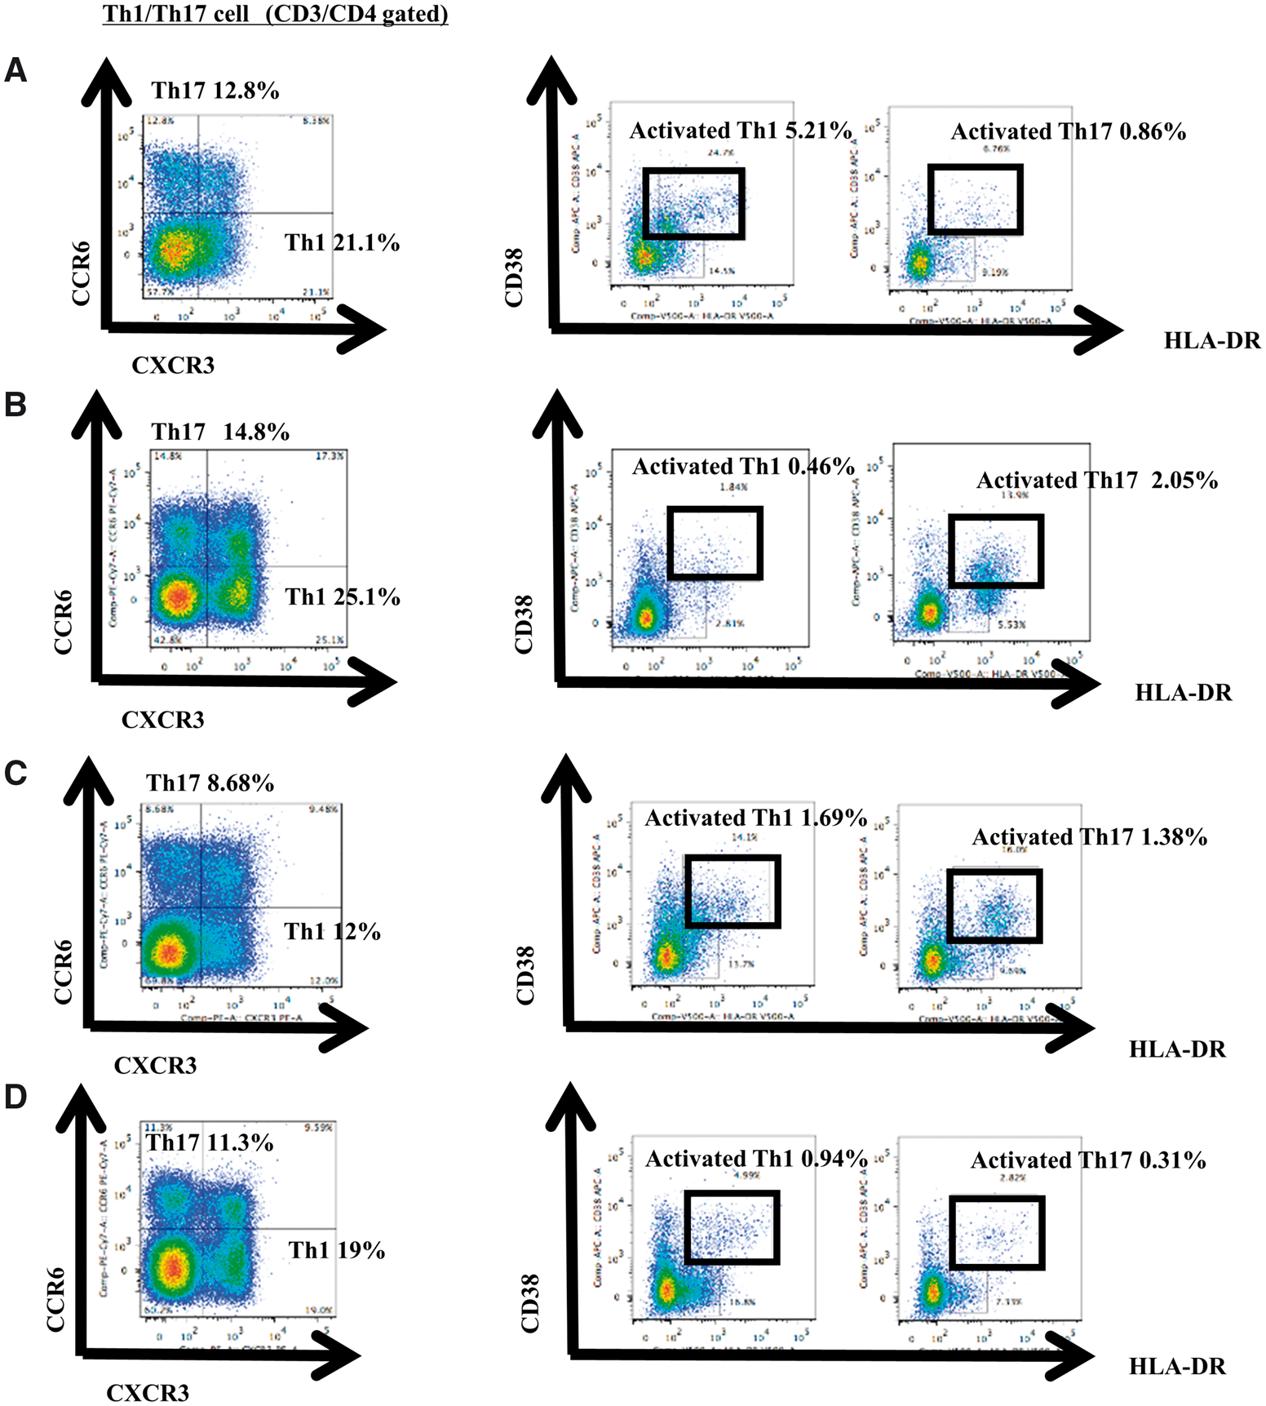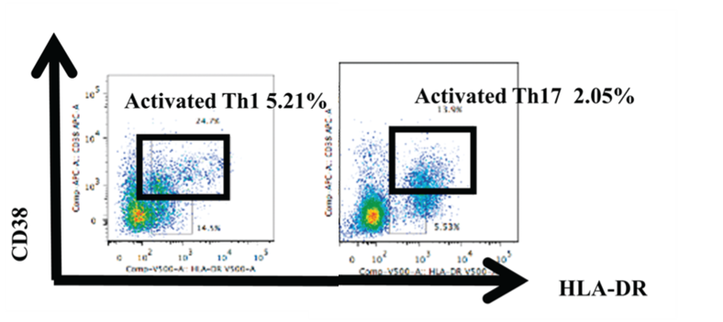

A

B

C

Fig.1: Proportions of activated Th17 and activated Th1 cells may predict response of AS patients to treatment with Secukinumab and Adalimumab, respectively. (A) Representative flow cytometry plots showing activated Th17 and Th1 cells. (B) Proportions of activated Th17 and Th1 cells at baseline in AS patients and (C) Comparison of proportions of activated Th17 and Th1 cells pre- and post-BDMARD treatment